**TEST PLAN :** defines your testing team’s test strategy, goals, and scope, which ultimately work together to ensure that all your software components are tested sufficiently before a release.

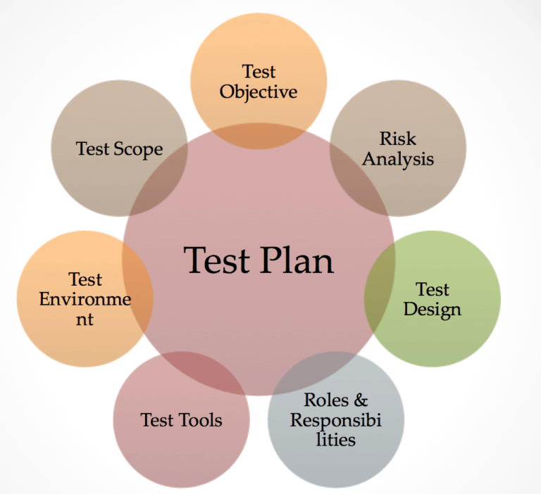

**1.Test Strategy**: The test plan defines the overarching strategy for testing, including the types of testing to be conducted (e.g., functional testing, performance testing, security testing) and the testing methodologies and techniques to be employed (e.g., manual testing, automated testing).

**2.Test Goals**: The test plan establishes clear goals and objectives for the testing effort, such as validating functionality, ensuring reliability and stability, verifying performance and scalability, and assessing security vulnerabilities.

**3.Test Scope**: The test plan defines the scope of testing, including the specific features, functionalities, and components of the software that will be tested. It also identifies any boundaries or limitations to the testing effort.

**4.Test Schedule**: The test plan includes a timeline for testing activities, including milestones, deadlines, and checkpoints. This schedule ensures that testing is conducted in a timely manner and that there is sufficient time to address any issues or defects that arise during testing.

**5. Test environment & Test Data**: refers to the hardware, software, and network configurations set up specifically for testing purposes.

* **Test data** refers to the data that is used specifically for testing purposes during software development and quality assurance activities.

**How to create a test plan?**

**Step 1: Define the Purpose and Scope**

* Understand the purpose of the test plan, whether it's for a specific project, product release, or system upgrade.
* Define the scope of the testing effort, including the features, functionalities, and components that will be tested.

**Step 2 : Schedule Timelines**

* Establish a timeline for the testing phase, including start and end dates, milestones, and checkpoints.
* Allocate time for test planning, test execution, defect management, and reporting activities.
* Consider factors such as project deadlines, resource availability, and dependencies with other project phases.

**Step 3 : Define Test Objectives**

* Outline the primary objectives of the testing effort, such as verifying functionality, ensuring reliability, validating performance, and assessing security.
* Specify any secondary objectives, such as compatibility testing, usability testing, and regression testing.
* Define specific metrics or criteria to measure the success of the testing efforts and assess whether objectives are met.

**Step 4 : Determine Test Deliverables**

* Identify the key deliverables that will be produced during the testing process, such as test plans, test cases, test scripts, test reports, and defect logs.
* Define the format, structure, and content of each deliverable to ensure clarity and consistency in documentation.
* Specify the stakeholders who will receive and review each deliverable and establish communication channels for distribution.

**Step 5 : Design the Test Strategy**

* Define the overall approach to testing, including the types of testing to be conducted (e.g., functional testing, performance testing, security testing).
* Determine the testing methodologies and techniques that will be used (e.g., manual testing, automated testing) and their respective roles in the testing process.

**Step 6 : Plan Test Environment and Test Data**

* Define the hardware, software, and network configurations required for testing, including testing environments, tools, and equipment.
* Ensure that the test environment closely resembles the production environment to ensure accurate testing results.
* Identify the test data required for testing, including representative datasets that simulate real-world scenarios and usage patterns.

**Verification and Validation :**

**Verification :**

* Verification ensures the software is built correctly according to specifications.
* Verification answers the question, **"Are we building the product, right?"**
* Activities involved in verification include reviews, walkthroughs, and inspections of documents, code, and other artifacts to identify defects, inconsistencies, or deviations from requirements.

advantages of verification in software development :

1. Early defect detection
2. Improved quality
3. Increased confidence
4. Risk reduction
5. Efficiency improvement
6. Compliance assurance
7. Documentation enhancement

**Validation :**

* validation ensures it meets the user's needs and expectations.
* Validation answers the question, **"Are we building the right product?"**
* Activities involved in validation include testing the software against the user's requirements, conducting user acceptance testing (UAT), and verifying that the software satisfies the customer's needs.

advantages of validation in software development :

1. Ensures the right product is built
2. Confirms user needs and expectations
3. Increases customer satisfaction
4. Reduces rework and cost overruns
5. Enhances product-market fit